Problem1

Its name comes from the word "ubuntu" in Zulu or Hausa in southern Africa, which means "humanity" "I exist because of everyone's existence". It is a traditional value in Africa. The term Ubuntu is regarded as a traditional African national concept. It is also regarded as one of the founding principles of the Republic of South Africa.

Its core concept is "treating people humanely", focusing on mutual loyalty and communication between people. South African President Mandela explained this: Ubuntu is a concept that includes many connotations of respect, mutual assistance, sharing, communication, care, trust, and selflessness: Ubuntu is a way of life that promotes tolerance and compassion for others

Problem 2

We could use channel “|” pass last output to cut command.

cat / etc / passwd | cut -d“：” - f1

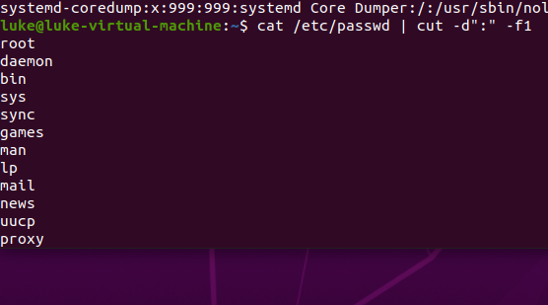

选出：之前的

Added following sentence.

| field1.txt

We have:

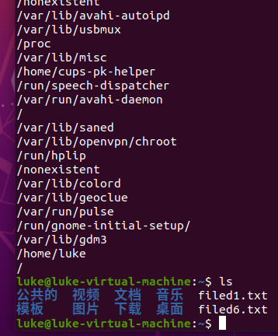

Tab character we could use “\t”

Such as:

echo -e "a\tb"

Linux paste command can integrated columns

paste -d \\t f1.txt f2.txt # 把f1和f2 按列合并， 用\t分割 显示合并后的文件内容。 cat是按行合并

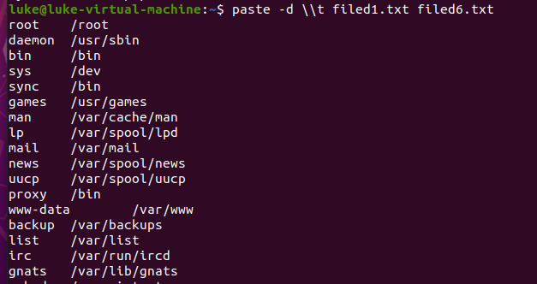

Write into file, we add

| field1and6.txt

### Problem3

Run :

expand -20 contain1and6.txt

the result is following:

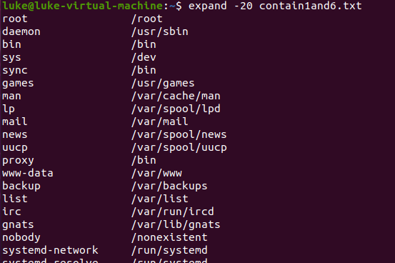

Problem4

We just change “\t” to “\n” ,

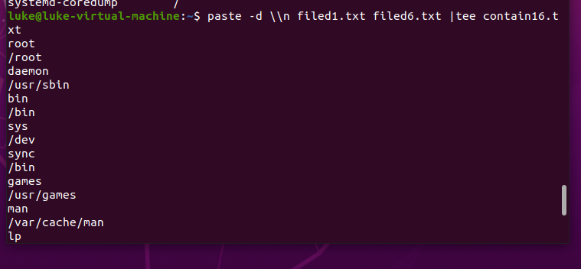

Problem 5.

Watch the video Revolution OS, and briefly answer,

1) what application greatly motivated companies to use Linux instead of Windows?

Apache

2) (optional) what Richard Stallman means in his Han Solo analogy when FSF is given the Linus Torvalds Award?

Actually Han Solo assisted the Rebel Alliance to destroy the Death Star, Han Solo should be awarded the Rebel Fleet Alliance Award, instead of Rebel fleet was given the Han Solo Award.

Linus Torvalds help FSF a lot. Richard Stallman thought that instead of giving the Linus Torvalds Award to FSF, Linus Torvalds should be awarded the Award.